Face Recognition System

I’ve made this Face Recognition System Using MobileNet.

I’ve used the weights of MobileNet and added my dataset of images using Transfer Learning.

This Face recognition code works on categorical values, i.e. I’ve used two categories in image dataset named:

-Abhishek Shrimal

-Rohit Sharma

This code includes python libraries listed below:

Cv2, numpy, keras, pillow, etc

This Face Recognition code also uses “haarcascade_frontal_face.xml” for detection of frontal face while creating the dataset.

The snaps of the code are listed below:

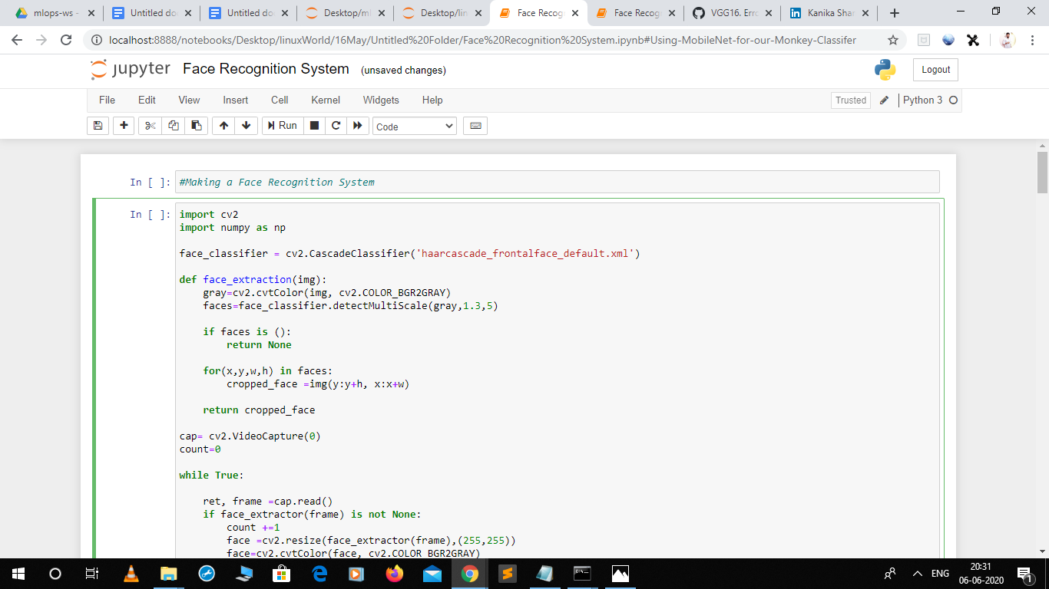

The above code states that we are storing our data in the form of images, i.e. creating our personal dataset.

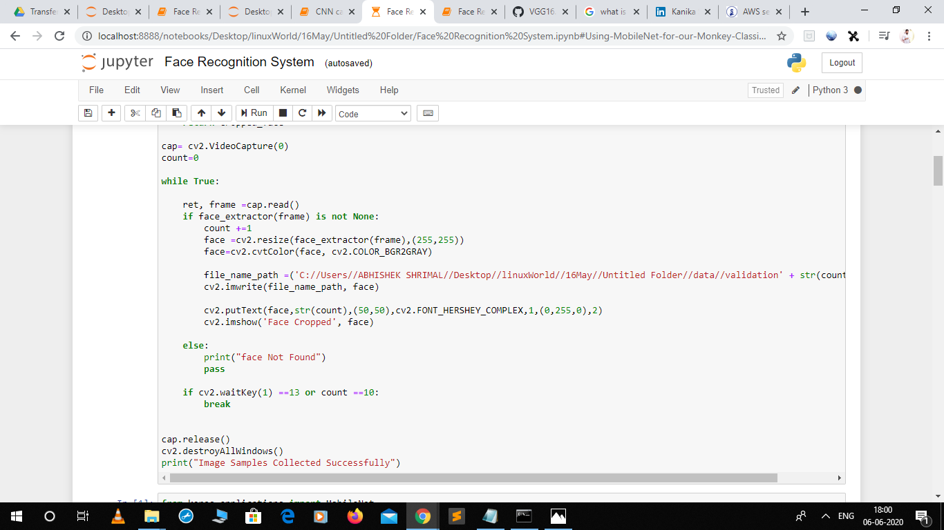

Here, we are making all the layers to not-trainable and having the list of the layers in the model.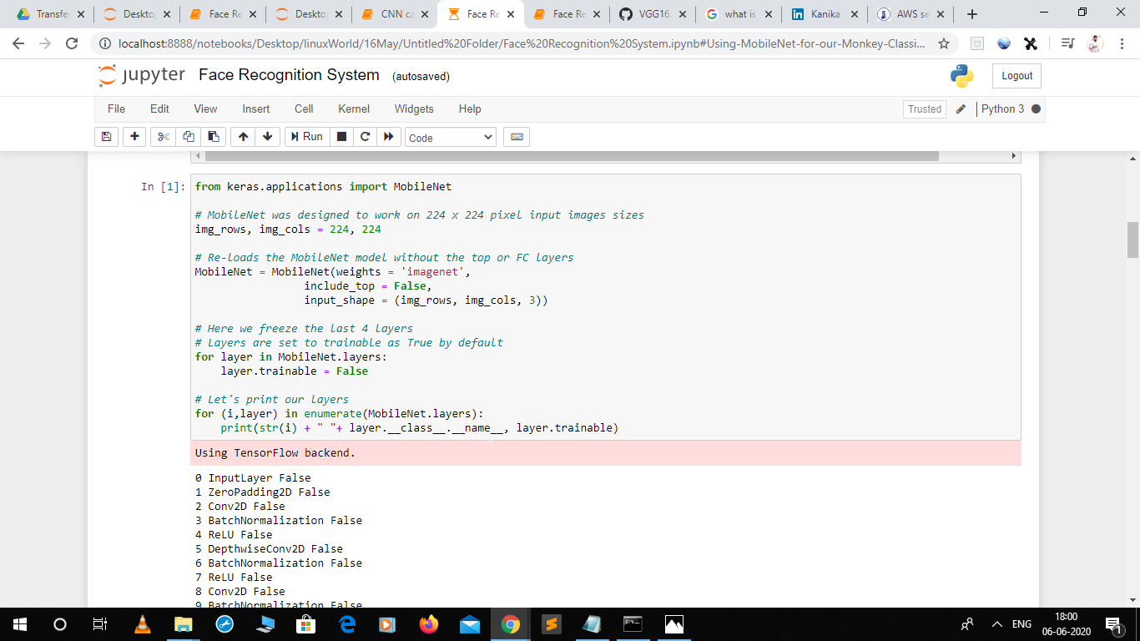

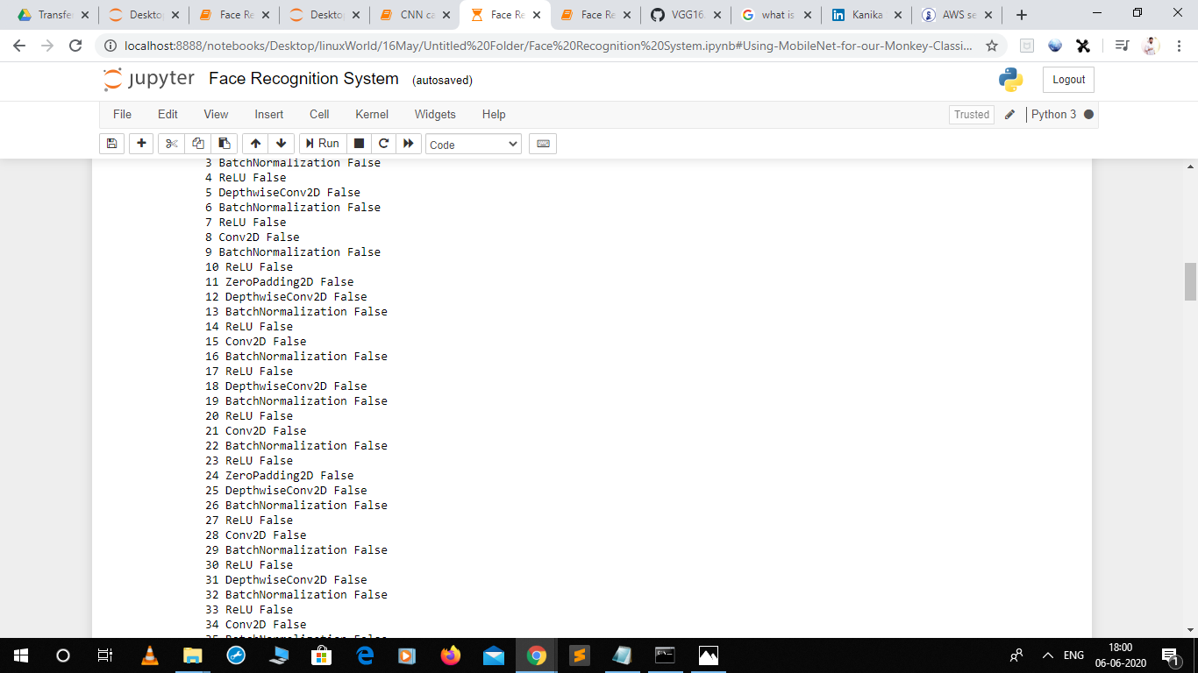

These are the list of the layers in our dataset.

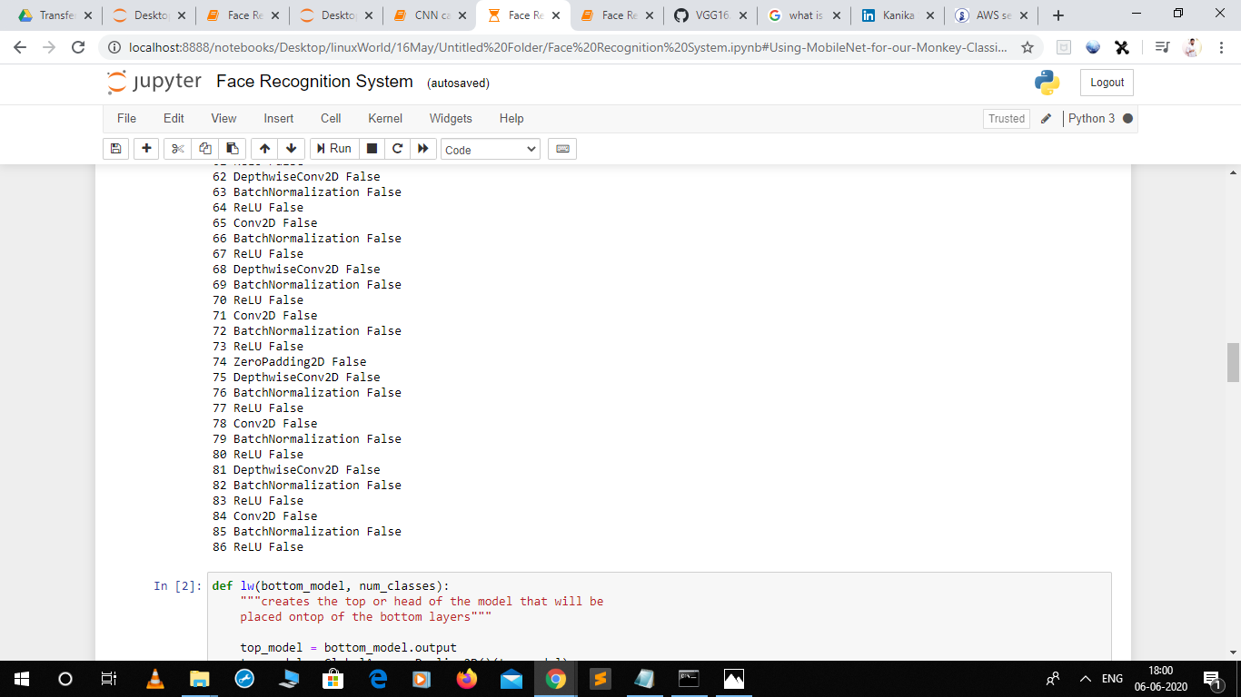

Now, we are adding our own layers and the dataset and calculating the weights by doing epochs.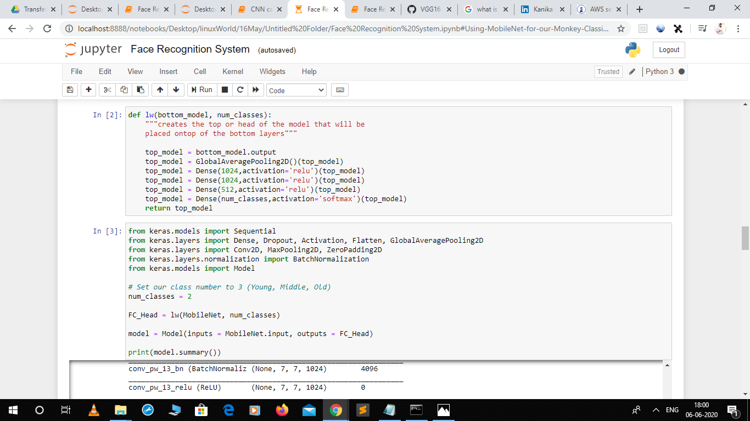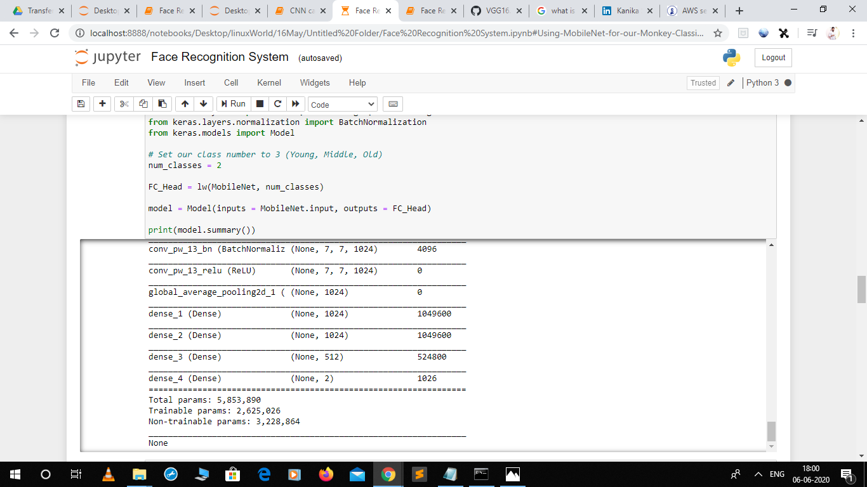

Now, we are adding those layers in the pre-created MobileNet model by Transfer Learning.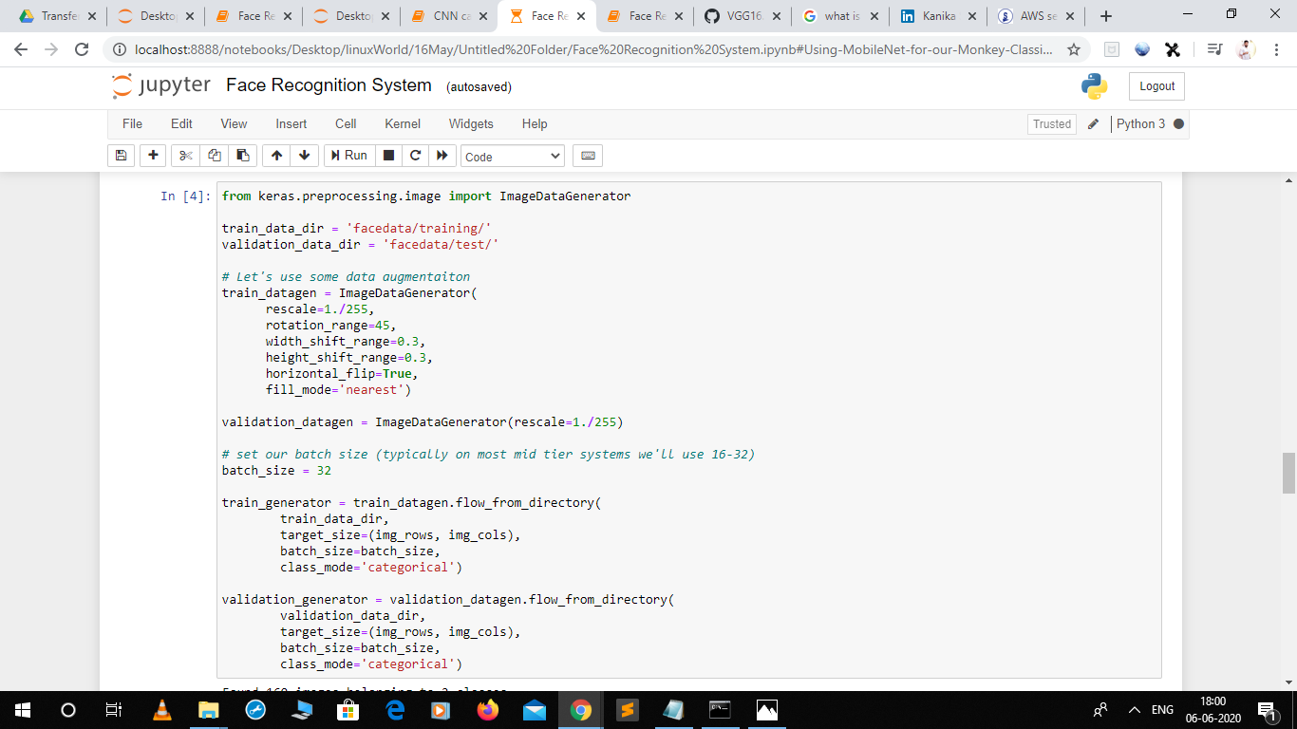

After Loading the images our model got to know that there are 2 classes of images in our dataset.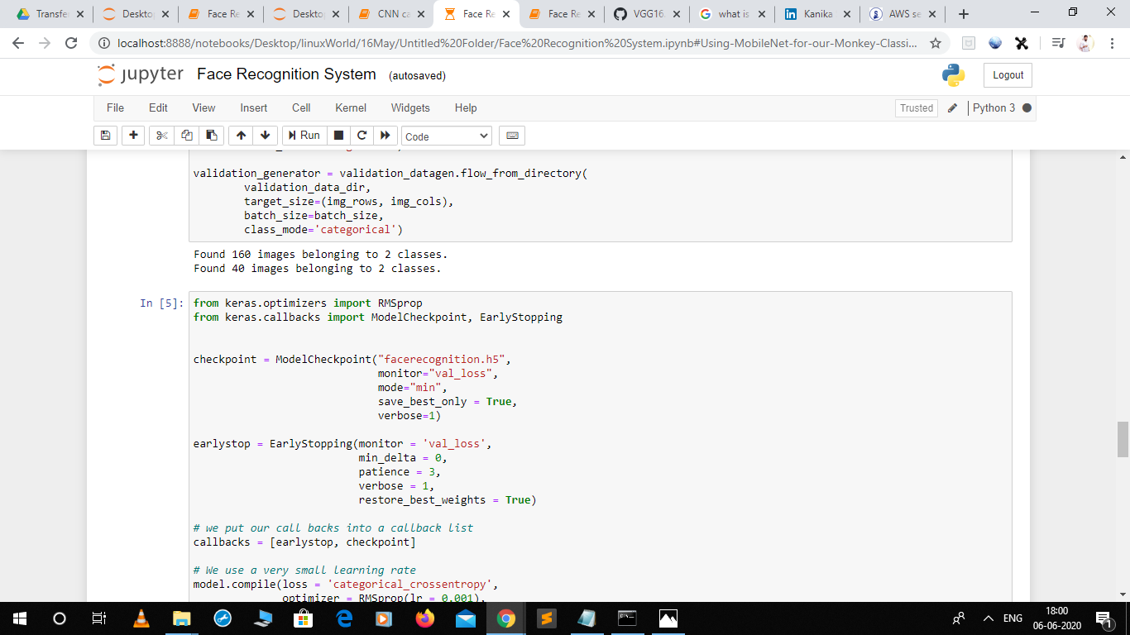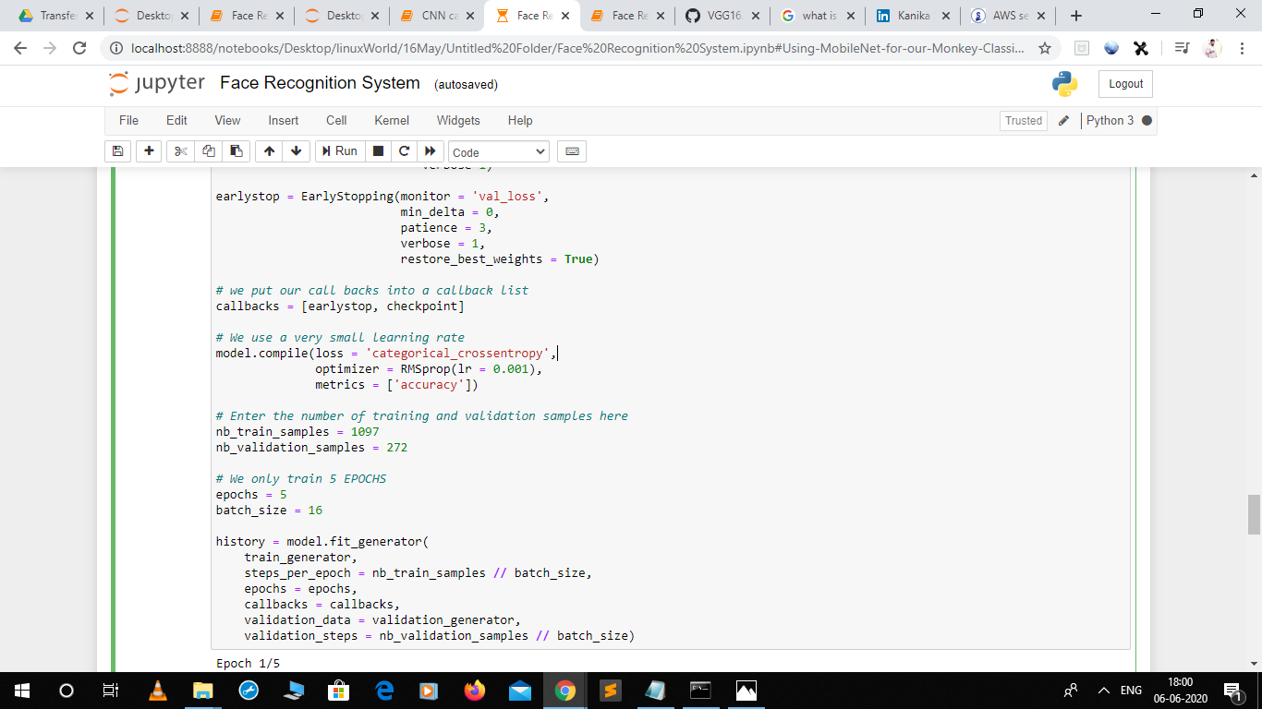

After 5 successful epochs we got the accuracy to be 98.94%.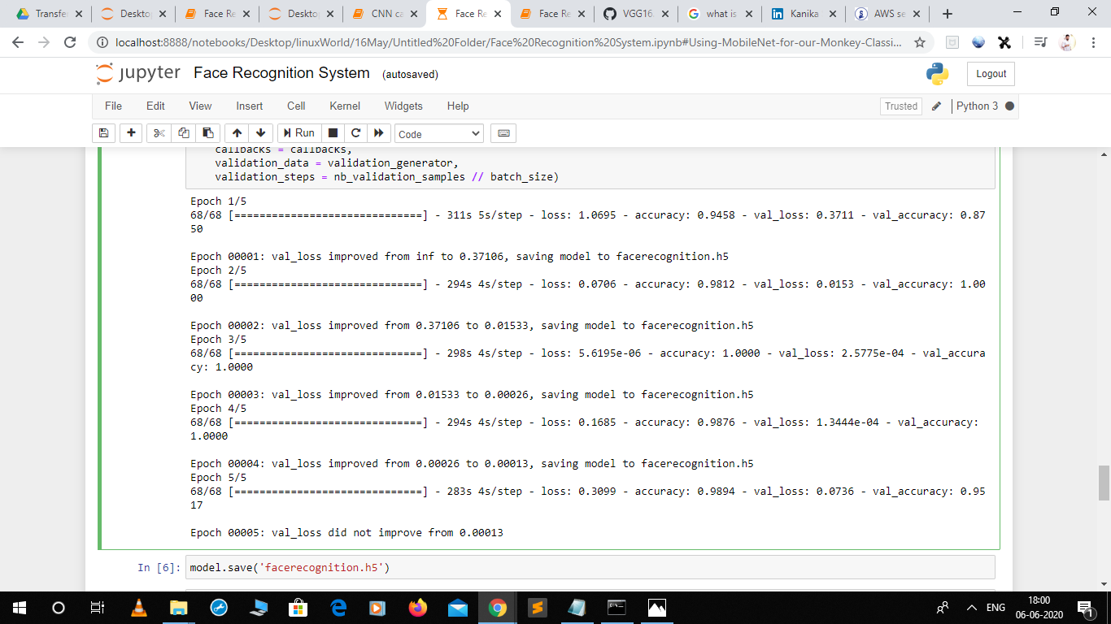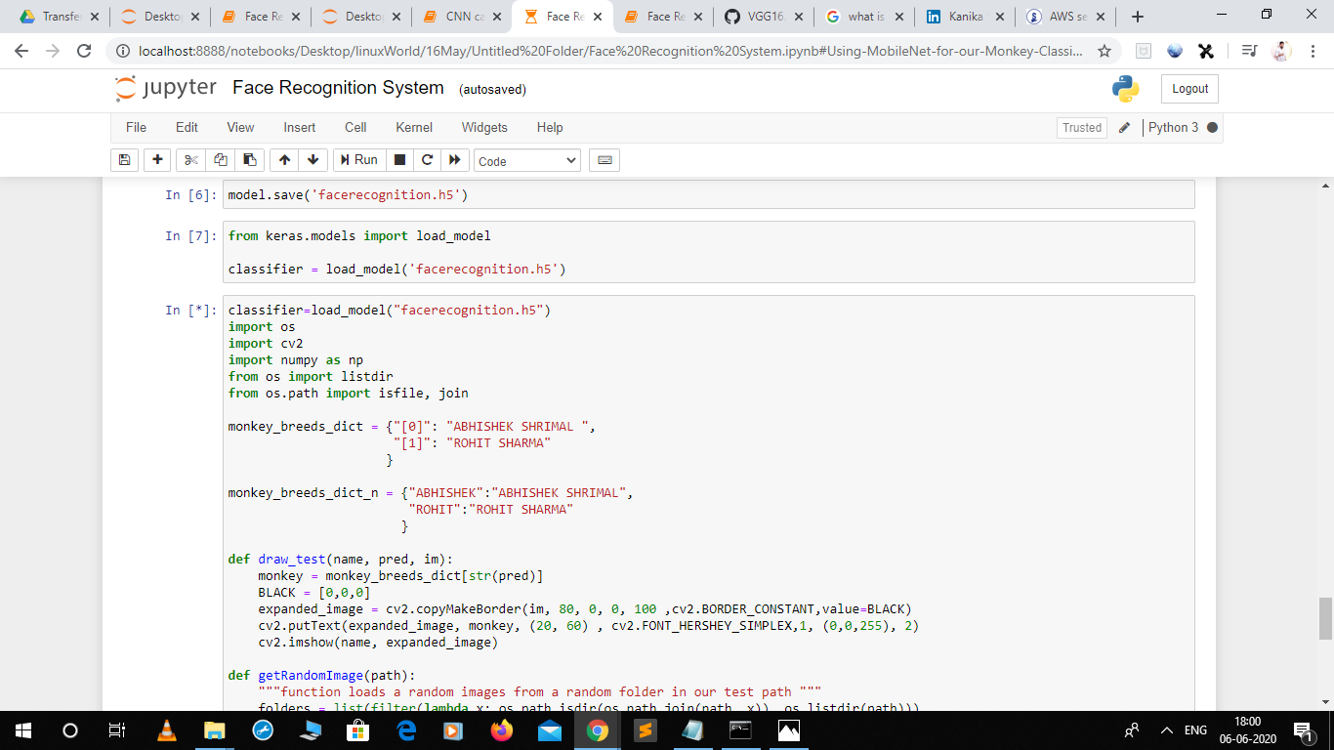

Finally, we’d calculated the weights of our dataset and stored that in “facerecognition.h5” file which can be further used in the model.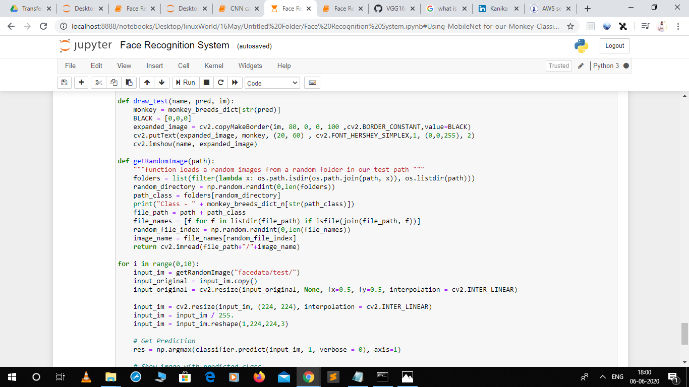

Now, our model is created and we can use the wieights of our model further and test it’s accuracy.

This can be done with the help of cv2 or pil libraries of python.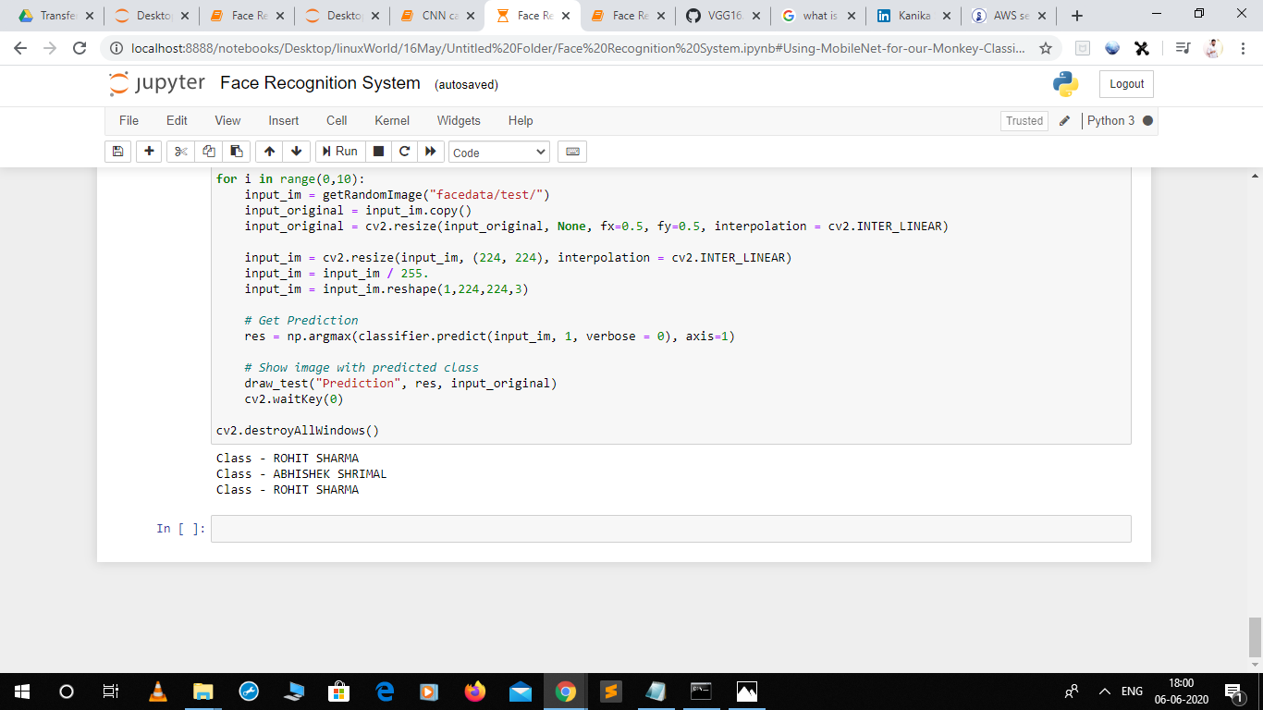

Hence, our model is successfully and accurately recognizing the face.